Both of the distribution is very important in probability distribution, All the ML algorithm needs the normalized data to learn it smoother, if the data is not normally distributed than it will be distributed by some techniques.
Example normal distribution:
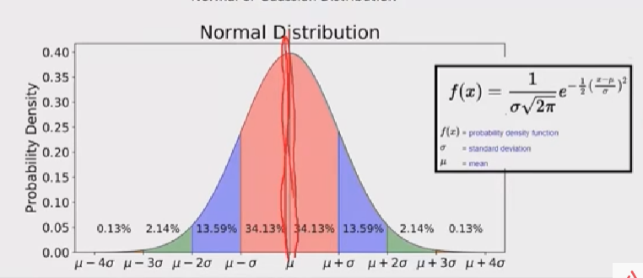
From the above image we can know that normal distribution is found from the mean value of balanced curve.
In below chart we can know that most of the values from range -2 to +2 are normally distributed.
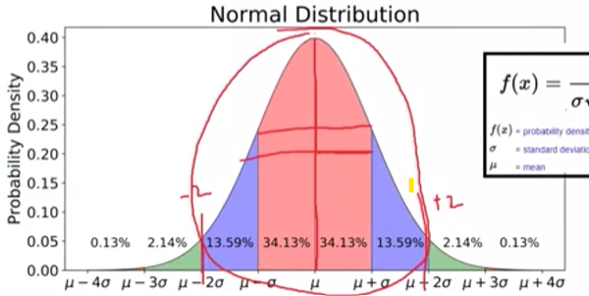

WHY NOMRAL DISTRIBUTION IS NEEDED FOR ML
From the concept of central limit theorm, the mean of a particular data in a dataset will be normally distributed even the dataset itself is not normally distributed.
Central limit theorm
The Central Limit Theorem says that if you take many averages from any type of data (like number of calls per hour or coin tosses), those averages will form a bell-shaped curve (normal distribution), even if the original data isn’t bell-shaped.
Example: If you roll a die many times and record the average of every 30 rolls, those averages will look like a normal curve—even though a single die roll is not normally distributed.

• Poisson distribution: Models the number of times an event happens in a fixed interval of time or space.
Example: Number of customer calls received per hour at a call center.
• Binomial distribution: Models the number of successes in a fixed number of independent yes/no trials.
Example: Number of heads in 10 coin tosses.
• Exponential distribution: Models the time between events in a Poisson process.
Example: Time between incoming calls at a help desk.
• Negative binomial distribution: Models the number of trials needed to get a fixed number of successes.
Example: Number of coin tosses needed to get 3 heads.
TYPES OF DISTRIBUTION
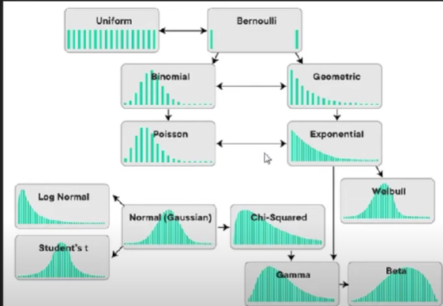
All these distribution are changes to the normal distribution to build good prediction model.

